

|  |
| --- |
|  |
|  |
| 2019 |



ZAIN EL-MASRI

# Table of contents

Table of contents 2

Design Brief: 3

A brief outline of what we are intended to do 3

Area of Investigation 4

Evidence of research 4

Design Sketches and final concept design 7

Hand sketched concept designs of the website & logo with feedback 7

7

Design changes 11

Identify variations between your final concept design and final product. Explain why these changes were made and how they impacted the final product. 1-2 pages 11

My Home page design changes 12

Evaluation 15

Describe good and bad features of your final product with reference to your research. Identify improvements that could be made to your design. 15

Bibliography 16

# Design Brief:

|  |
| --- |
| A brief outline of what we are intended to do Flynn's Arcade has been slowly losing money as the trend for accessing video games has moved away from social 'video game arcades' to at home 'video game consoles' such as the Atari & Commodore 64. Flynn wants to reposition his business as a venue for selling new games and trading used games. Flynn wants you to design and create ‘alpha phase’ website that communicates his new business model. |
| More information on Flynn’s Arcade: (<http://tron.wikia.com/wiki/Flynn's_Arcade>) |
| Criteria  * Construct a website and a detailed portfolio that suits the design brief * Related imageDo a Substantial amount of work * Seriously attempt everything * Use html and css to design your website * Dsfg * dfgs |

# Area of Investigation

# Evidence of research

Comparison of website creation tools

(IDE, CMS, Drag and Drop)

|  |  |  |  |
| --- | --- | --- | --- |
| Image result for notepad++ logo | Related imagegf | Image result for wix logo | Image result for dreamweaver logo |
| Notepad++ is a text and source code editor used on Microsoft windows. It is one of the most useful software’s when it comes to coding websites exactly how you want them.  It has been downloaded over 28 million times all around the globe. | With more than 50m websites built Weebly is one of the largest website builders. Weebly is specifically focused on online shopping, it has a very clear interface and is for less professional web creations. | Wix is a very popular cloud-based website development platform that serves millions of users from all over the globe. it allows users to create HTML5 websites and mobile sites using online drag and drop tools, it is also used to create small websites. | Dreamweaver is a software for creating and designing web pages created by adobe, Dreamweaver is the most complete toolset for professional website designers. |

|  |  |  |  |  |
| --- | --- | --- | --- | --- |
| Price | Free of charge | From $15/mo | From $10/mo | From $29.99/mo |
| Released | 2003 | 2006 | 2006 | 1997 |
| Features | * Source code editor * Syntax highlighting * autosave * Simultaneous editing. * Easy publishing * Limited autocompletion * Split screen editing and synchronized scrolling. * Code folding | * Drag and drop website builder * eCommerce Store * Responsive templates * App integration * Easy publishing * Domain registration * Free Sub-domain * Full-width page editor * 24×7 Support | * Drag n’ Drop Website Editor * Intuitive Website Builder * 100s of Designer-Made Templates * Customizable Designs * Free and Reliable Hosting * Image &Text Editor * Free Fonts * Organize Pages | * Code Completion * Code Collapsing * Developer Workspace * Real-Time Browser Preview * Quick CSS Editing * Type kit Marketplace * Code Themes * Starter Templates * Multi-Monitor ­­ |

What is Drag and drop, IDE, and CMS?

Drag and drop is a functionality by which users can select an object or a section of text and can move it to a desired location and "drop" it there. Using the drag and drop method is intended to be simple for users to move or copy items, in this case the website makers make it super simple for their customers by being able to bring a button into your website by just dragging it instead of making all the coding for it.

An integrated development environment (IDE) is a software suite that combines basic tools required to write and test software.

A content management system (CMS) is a software application or set of related programs that are used to create and manage digital content.

Overall these are all factors of the website making companies, making several stuff really easy for their customers, as easy as dragging a button that normally takes at least 10 minutes to code.

Flynn and his design aesthetic

Firstly, who is Kevin Flynn?

Kevin Flynn was a gifted computer programmer, he was hired by ENCOM and started developing amazing new games in secret, a competing ENCOM programmer named ed Dillinger learned what Flynn was doing and three months later Dillinger unveiled the games to the company and acted like they were his he was quickly promoted eventually rising to senior executive vp. When Flynn protested Dillinger fired him, Flynn then made his own establishment named Flynn’s arcade and filled it with his own creations alongside other arcade machines. Flynn created TRON, an arcade game based on his experience inside the computer world alongside the TRON program, and it got globally famous.

Flynn’s design aesthetic is influenced by the 70s and 80s along with a very futuristic, and technologically advanced vibe.

Data communications and its implications for web design

**Data communication** refers to the exchange of data between a source and a receiver, in other words, the sharing of a virtual message. Electronic communications, like emails and instant messages, as well as phone calls are examples of data communications. Data communications gives you the ability to easily stay in touch with others. Phones, instant messaging, emails and social networking sites all utilize data communications. So, this would be a good way for web owners to stay in contact with their customers/viewers, or for web designers who make contact pages.

# Design Sketches and final concept design

# Hand sketched concept designs of the website & logo with feedback

# 

After a lot of thinking and designing I drew these two logos and asked my classmates for feedback on which one they preferred and what I could improve, they said:

|  |
| --- |
| “I really like the one on the right I just think that the font should be thicker”  “I like the one on the left because the packman and ghost replacing the c and a”  “I like them both, I can’t choose!”  “I like the one on the left, it looks cool” |

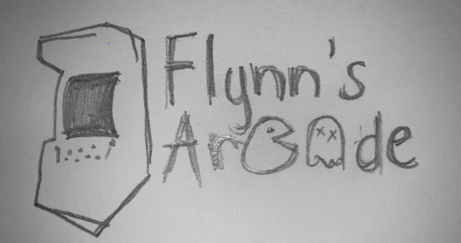then I thought to myself how about if I changed the controller into something else? I was looking through the icons under gaming, and then I saw an arcade machine, so I drew an example to see how it looks and I really liked it, so I decided to use it….

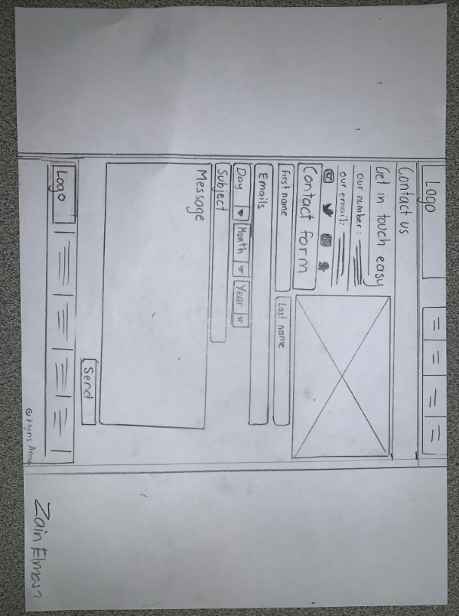

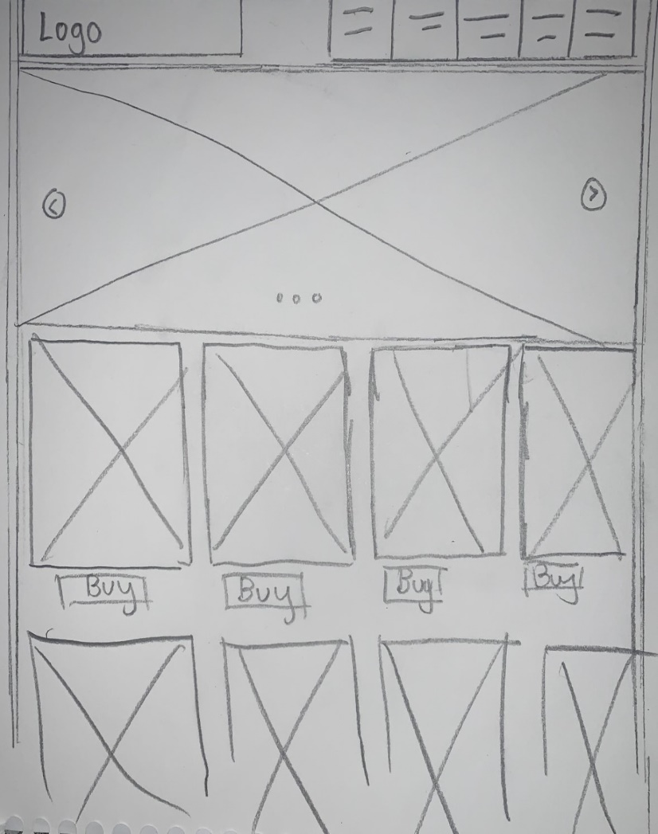

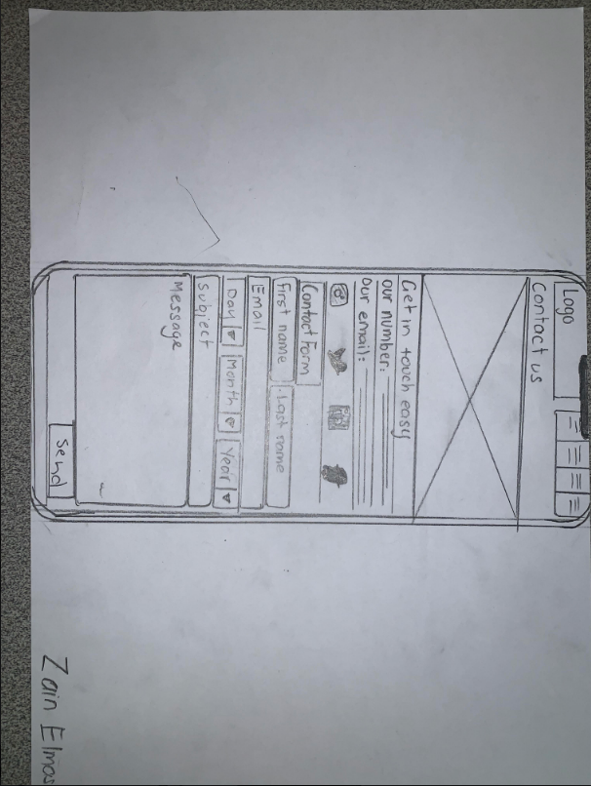

These are my website design sketches of how my websites home and contact page will look, they were all inspired by the JB-HI-FI website. The one in the middle is the layout for a phone and the other two are how my website would look on a desktop, feedback I got was:

|  |
| --- |
| “It looks very neat, and has great formatting”  “Very detailed” |

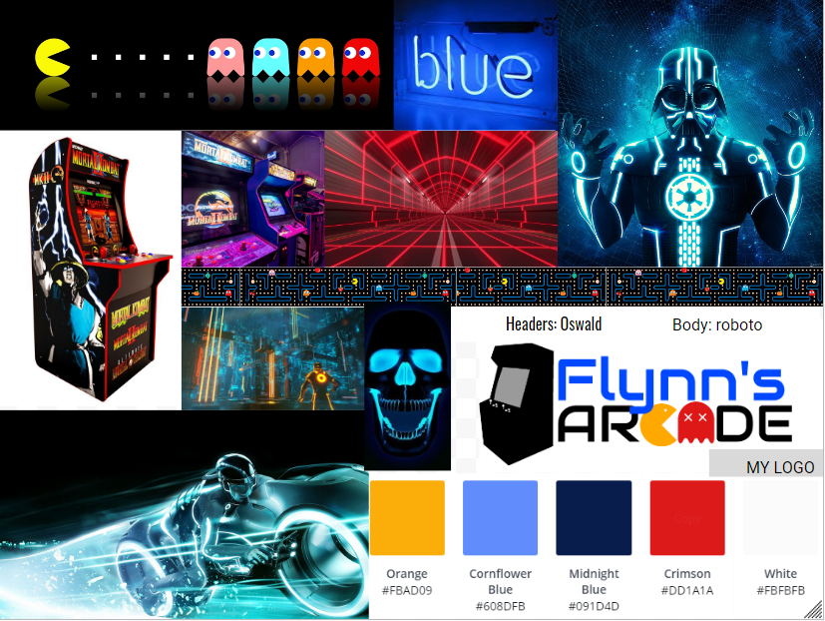My Mood Board

I wanted my mood board to be unique and to have cool colors, my mood board was deeply inspired by the 80s retro kind of pacman aesthetic, at the same time of being in the neon, innovative, technologically advanced, Tron world.

# Design changes

# Identify variations between your final concept design and final product. Explain why these changes were made and how they impacted the final product. 1-2 pages

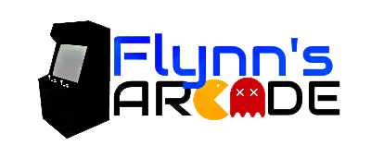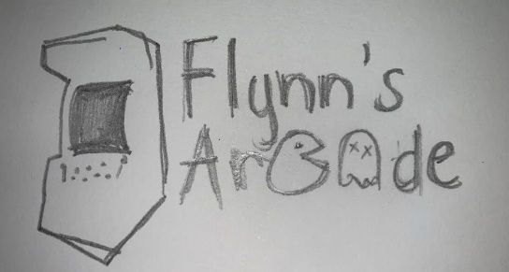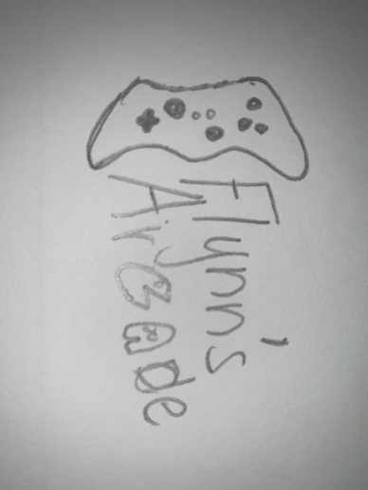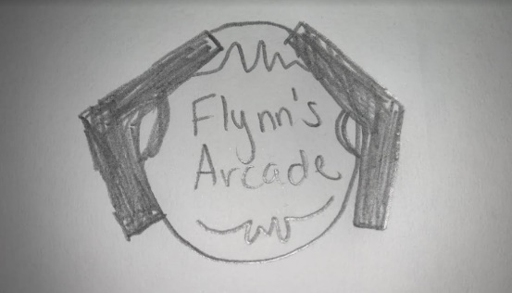I made A LOT of changes throughout the planning and production of my website

Firstly I changed my whole design of the logo, I drew three sketches and was choosing from them but as I was asking for feedback and giving feedback to my classmates, wherever I’d walk around the room I’d see gaming controllers and arcade guns on logos, on nearly every screen, that’s when I got the inspiration to do something different and unique, I then changed design 1 with an arcade machine considering the websites actual name ‘Flynn’s Arcade’. I added colors from my color palette and that was my final logo. I constructed my logo on a website called “LogoMakr” (<https://logomakr.com/>)

My Home page design changes

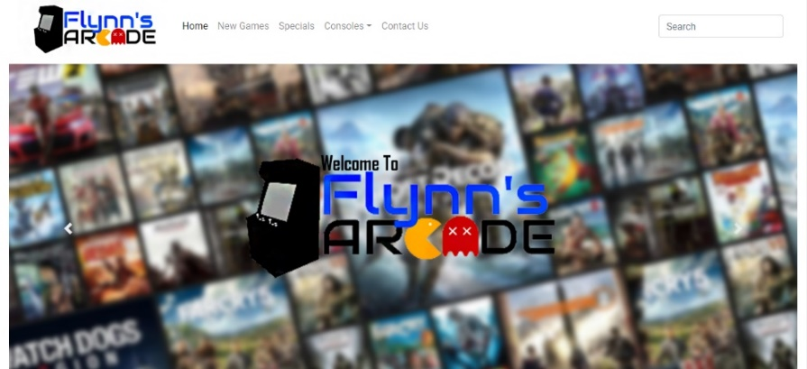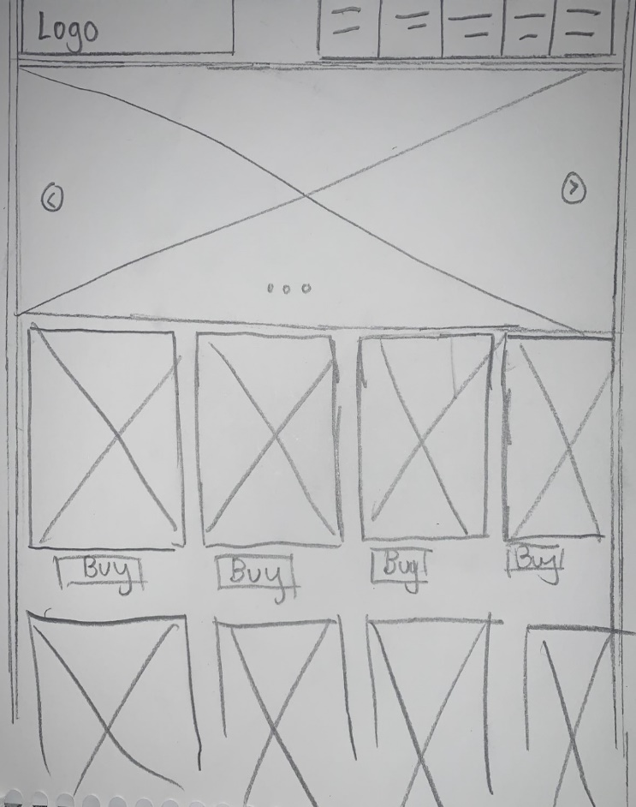

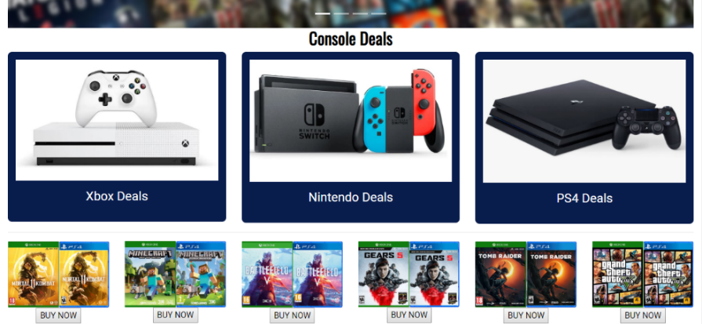

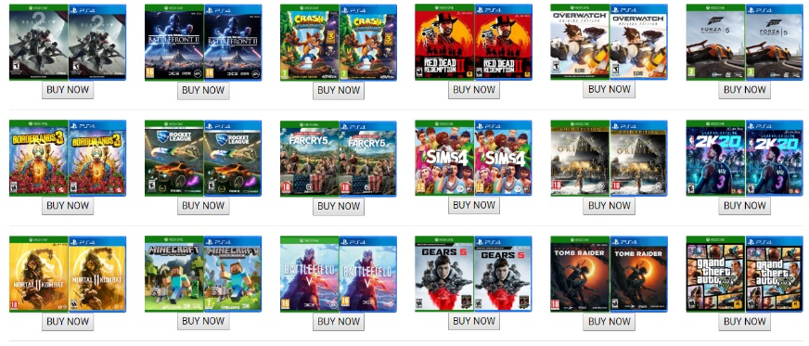

* I added a search bar­ in the header

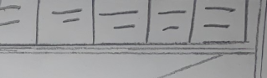

* I added a part before products advertising Flynn’s arcade console deals

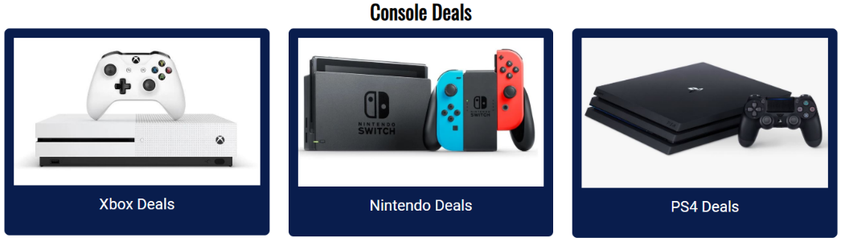decided to add a console

deals section because every

game seller doesn’t sell

games without something to

play them on…

* I added the disc case for both Xbox and ps4 instead of one

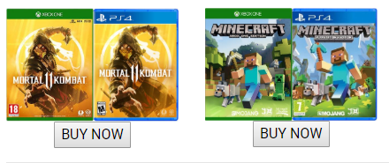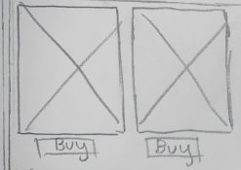

Decided to add discs for both consoles because some customers may not play on the console I would’ve put.

* I added six products in one row instead of my original number of four

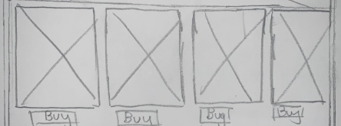

I decided to add two more games in a row because it looked more professional and spacious



* 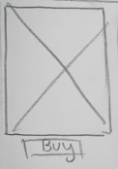 I changed the button from buy to buy

Now because it makes the website sound

more accessible

My contact page design changes

One of the biggest changes in my website is my contact page, I was expecting to make a contact form but I changed it into a contact us page, where I provided a number and email as well as the store location and opening hours, also added the social media icons they could just press on it and immediately be redirected to the

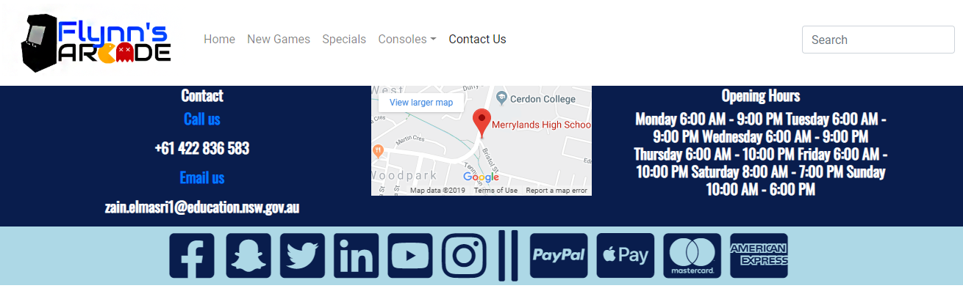

Next Page: Evaluation

# Evaluation

# Describe good and bad features of your final product with reference to your research. Identify improvements that could be made to your design.

My Website is overall pretty good and better than i expected it to be but there are definitely some things that could be improved.

Some good features of my website are the sliders which transition professionally from one slide to another from pictures I designed in photoshop, the variety and number of products I have (console deals and 24 games available), the logo, backgrounds, and text match the colors in my color palette, one more good feature is the social media icons on the footer which actually links to Facebook, Instagram, and YouTube etc.

Some features of my website that can be improved are the buttons, if more of the buttons worked it would make it so much more accessible, if I made it look more a bit professional, if my second 2 slides were mine too that would be more convenient, also something that could be improved is the quality of my footer, if it had more information about my company and had a better layout.

If my website was actually running an actual purchasing system, buttons that would link to more pages, and was a bit more professional I would probably buy something, because it would seem like a fully working website.

Overall, I enjoyed making and designing this website and hope to do a better one someday…

# Bibliography

Acknowledge ALL resources used. Web pages, Images, Books, Video’s, etc.:

<https://en.wikipedia.org/wiki/Wix.com>

<https://www.computerhope.com/jargon/d/dreamweaver.htm>

<https://www.hostingadvice.com/how-to/what-is-wix/>

<https://www.websitetooltester.com/en/blog/wix-vs-weebly/>

<https://www.techopedia.com/definition/6918/drag-and-drop>

<https://www.creativebloq.com/adobe/dreamweaver-web-design-tool-121518352>

<https://tron.fandom.com/wiki/Kevin_Flynn>

<https://www.youtube.com/watch?v=pDsta8UgWEI>

<https://www.websitebuilderexpert.com/website-builders/weebly/free-website-builder-for-all/>

<https://www.wix.com/upgrade/website>

<https://en.wikipedia.org/wiki/Adobe_Dreamweaver>

<https://www.g2.com/compare/adobe-dreamweaver-vs-wix>

<https://www.sitebuilderreport.com/weebly-review>

<https://www.codecademy.com/articles/what-is-an-ide>

<https://disney.fandom.com/wiki/Kevin_Flynn>

<https://www.webfx.com/blog/web-design/effective-communication-tips-for-web-designers/>

<https://www.imdb.com/title/tt1104001/plotsummary>

<https://getbootstrap.com/docs/4.3/layout/overview/>

<https://www.tutorialspoint.com/data_communication_computer_network/index.htm>

<https://logomakr.com/>